|  |  |  |
| --- | --- | --- |
| **Project Name: Abu Ghaleb bridge** | | |
| **Location:** | | |
| **Contractor**  **Rowad Modern Engineering** | **Consultant**  **Penta** | **Employer**  **General Authority for Roads and Bridges** |

|  |  |  |  |  |  |
| --- | --- | --- | --- | --- | --- |
| **Project Code** | **0167** | **Date:** | **28/12/2022** | **Report No.** | **62** |
| **Phase** | **1** | **Ref.** |  | **Attached doc.** |  |

# A. Management Staff *(Input by Timekeeper)*

|  |  |  |  |  |
| --- | --- | --- | --- | --- |
| ID | Position | Day Shift | Night Shift | Notes |
| 1 | عمال ذاتى | 6 |  |  |
| 2 | كهربائى تركيبات | 1 |  |  |
| 3 | فورمجيه خرسانه | 5 |  |  |
| 4 | لحامين | 2 |  |  |
| 5 | شده معدنيه | 0 |  |  |
| 7 | مساحه | 1 |  |  |
| 8 | مشرفين | 1 |  |  |
| 9 | الصحة والسلامة | 2 |  |  |
| 10 | مشرف امن ادارى | 1 |  |  |
| 11 | امن ادارى | 4 |  |  |
| 12 | مخزن | 1 |  |  |
| 13 | مشتريات | 1 |  |  |
| 14 | عامل سكن | 1 |  |  |
| 15 | مراقب وقت | 1 |  |  |
| *Totals of management staff* | | 32 | |  |

# B. Site Workers (Labors) *(Input by Construction Manager)*

|  |  |  |  |  |  |  |  |  |  |  |  |
| --- | --- | --- | --- | --- | --- | --- | --- | --- | --- | --- | --- |
| ID | Trade / Position | Subcontractor/Supplier Name | Location | No. of workers | Day Shift | Hours | | Night Shift | Hours | | Notes |
| 1 | Steel fixing | Sherbieny |  | 3 |  | |  |  | |  |  |
| 2 | Formwork | Gohary |  | 6 |  | |  |  | |  |  |
| 3 | Pile head demolishing | Mohamed Saber |  | 0 |  | |  |  | |  |  |

# C. Activities on Site *(Input by Project Control Engineer in coordination with Construction Manager)*

|  |  |  |  |  |  |  |  |  |
| --- | --- | --- | --- | --- | --- | --- | --- | --- |
| ID | Location | On site activities description | Date | | % complete previous | % Complete this day | To date % complete | Notes |
| Started | Planned Completion |
| 1 | Axis-P10-P12 | حفر و صب خازوقين | 25/12/2022 | 28/12/2022 | 100 | 100 | 100 | جارى حفر وتسليم خازوقين واجمالى الصب 162 خازوق |
| 2 | P04 | حدادة العمود | 11/10/2022 | 28/12/2022 | 20 | 0 | 20 |  |
| 3 | P03 | حدادة العمود | 12/10/2022 | 28/12/2022 | 20 | 0 | 20 |  |
| 4 | P02 | حدادة العمود | 12/10/2022 | 28/12/2022 | 30 | 0 | 30 |  |
| 5 | P20 | صب العمود | 16/11/2022 | 28/12/2022 | 95 | 5 | 100 |  |
| 5 | P22 | صب العمود | 16/11/2022 | 28/12/2022 | 80 | 5 | 85 |  |
| 6 | P23 | شدة العمود | 04/12/2022 | 28/12/2022 | 80 | 0 | 80 |  |
| 7 | P36 | حدادة القاعدة | 28/12/2022 | 28/12/2022 | 0 | 20 | 20 |  |
| 8 | P35 | حدادة القاعدة | 22/12/2022 | 28/12/2022 | 50 | 20 | 70 |  |
| 9 | P34 | حدادة القاعدة | 23/12/2022 | 28/12/2022 | 30 | 20 | 50 |  |
| 11 | P33-P34 | تكسير رؤوس خوازيق | 17/12/2022 | 28/12/2022 | 80 | 20 | 100 | تم ترتيب التكسير يوم السبت القادم |

# D. Equipment and tools list *(Input by Equipment Supervisor)*

|  |  |  |  |  |  |  |  |
| --- | --- | --- | --- | --- | --- | --- | --- |
| ID | Equipment *(heavy/small tools)* | Subcontractor Name | Type *(Rented/owned)* | Model | In use hours | Stand by hours | Notes |
| 1 | 2 Loader | Mobilization | Rented |  | 8 |  |  |
| 2 | Tractor | Removal | Rented |  | 8 |  |  |
| 3 | Excavator | Excavation | Rented |  | 8 |  |  |
| 4 | Mobile crane | Mobilization | Rented |  | 8 |  |  |
| 6 | 3 Water truck | Piles | Rented |  | 8 |  |  |
|  |  |  |  |  |  |  |  |

# Formwork *(Input by Formwork)*

|  |  |  |  |  |  |  |  |
| --- | --- | --- | --- | --- | --- | --- | --- |
| ID | Item Description | System | Subcontractor Name | Items Code | QTY | Location | Notes |
| 1 | ------------ |  |  |  |  |  |  |
| 2 |  |  |  |  |  |  |  |

# F. Delivered Material *(Input by site QC)*

|  |  |  |  |  |  |  |
| --- | --- | --- | --- | --- | --- | --- |
| ID | Material description | Material on site (Qty) *if applicable* | Delivered Qty Today | MIR No. | Supplier | Notes |
|  |  |  |  |  |  |  |
|  |  |  |  |  |  |  |

# G. Area of Concerns *(Input by Project Control Engineer)*

|  |  |  |  |  |  |
| --- | --- | --- | --- | --- | --- |
| ID | Concern description *(i.e., weather condition, delay, obstructions)* | Duration | Location | Impact | Notes |
| 1 | Shortage of concrete supply from ready mix stations (Payment issue, availability of sim 3) |  | General | Delay of piles works & Claims from driller on site | Settled |
| 3 | Mockup of mass concrete not started |  |  | Delay of all mass concrete works (Especially Pile caps) | Poured 24/9/22 |
| 5 | All requirements for Pile cap works ( Thermo cables-Earthing Drawing -qualified station for mass concrete) |  | Piles Caps |  | Settled |
| 6 | Pier forms |  |  | Delay of pier works | Deliverd |
| 7 | Bearings vendor not determined |  |  | Delay of piers & pier head |  |
| 8 | Forms of U-precast beam is top urgent to be procured |  |  | Delay of project as it’s critical activity. |  |
| 9 | Removal of 6 Residential buildings |  | P13-P19 | Delay of piles works |  |
| 10 | Removal of Water station fence |  | P5-P8 | Delay of piles works |  |

Prepared by: Approved by: Approved by:

Project control engineer Construction Manager Project Manager

Signature Signature Signature

Date Date Date

# H. Site photos:

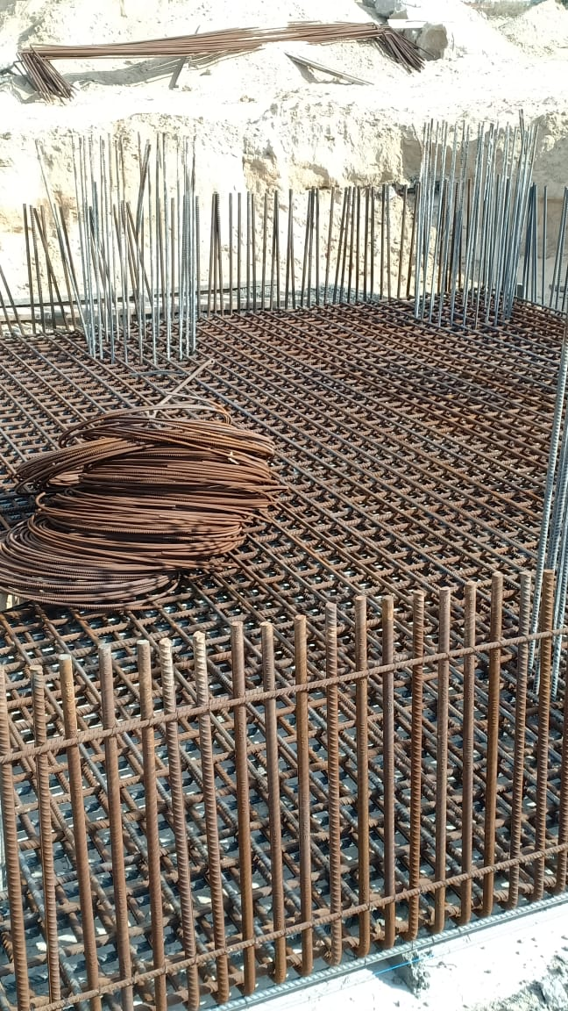

Steel fixing of pile cap P-35

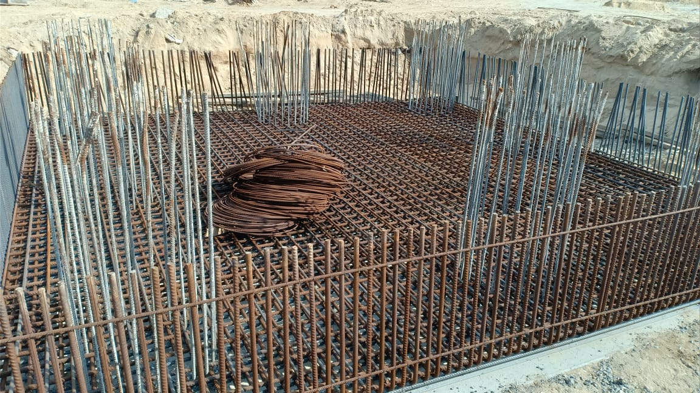

Steel fixing of pile cap P-35

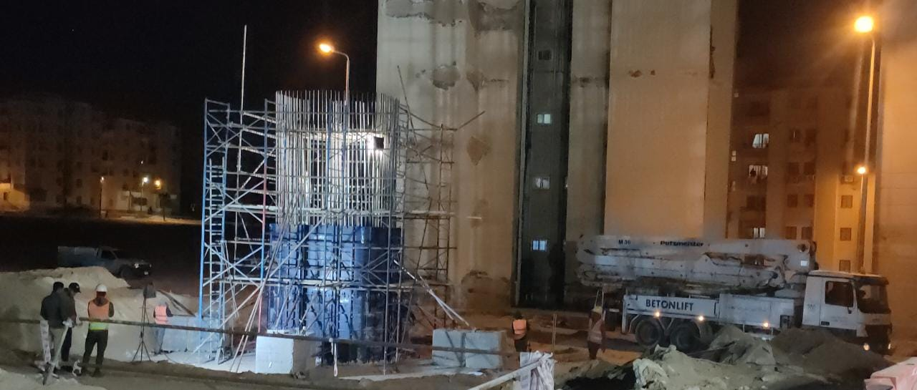

Pouring of column P-20

Pouring piles P19-P12

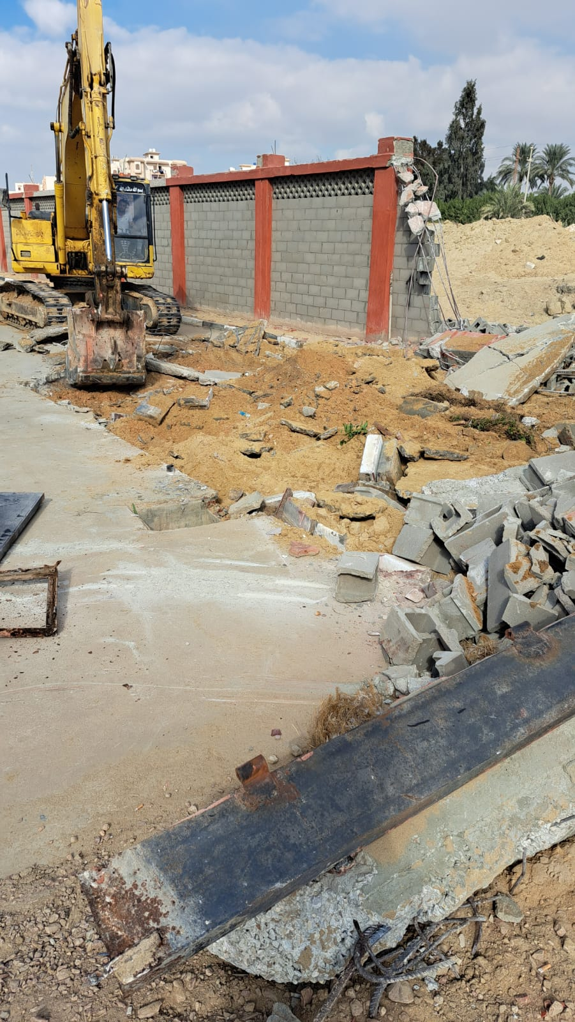

Demolishing Water station fence for piles work